Marisa Kuyava

Project Proposal

SNHU CS 330

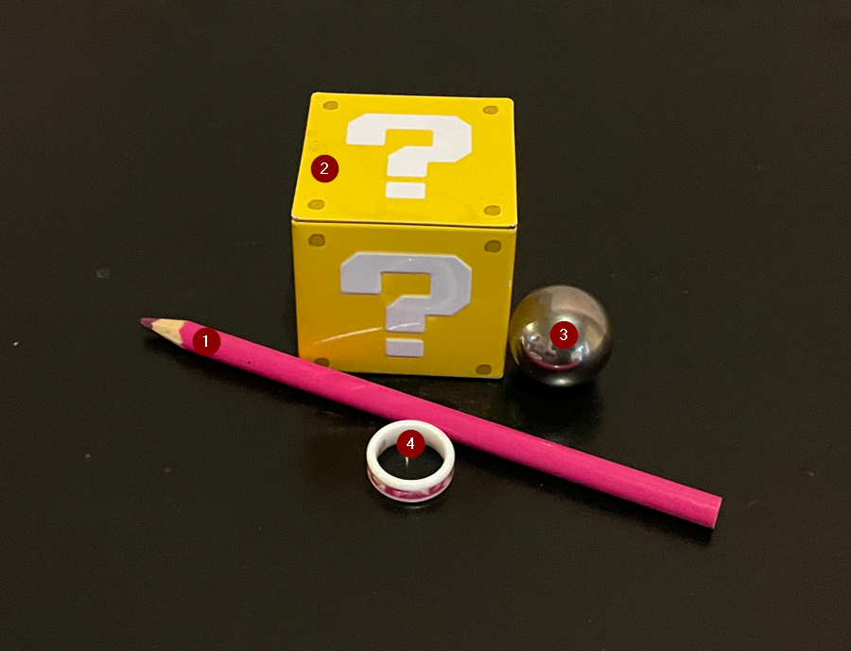

I plan to use the photo above for my 2D to 3D conversion scene. I selected these items for my project because they will be easy to construct with primitive shapes and will give me experience with creating a variety of object shapes. The photo includes five objects including the background:

1. Colored Pencil
   1. This will be created from a Cylinder for the main portion, a Pyramid for the wooden tip with another Pyramid overlayed for the pink pencil tip.
   2. This will be my item that is created from multiple shapes.
2. Yellow Question Box
   1. This will be created from a Cube
   2. Possibly will leave off ‘?’ to simplify
3. Silver Ball
   1. This will be created from a Sphere
   2. Surface of the ball/color will be silver and not reflective
4. Wedding Ring
   1. This will be created from Torus
   2. Possibly will leave out some of the texture details on the pink band to simplify
5. Table Background
   1. This will be created from a Plane
   2. The white wall and any other background seen in the image will be modified to be the same as the table (black)

